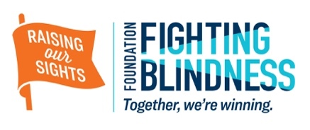
Financial support is key to maximizing the fundraising efforts of [EVENT NAME benefitting the Foundation Fighting Blindness]. We are seeking sponsors to help us underwrite costs and contribute to the silent auction. The event is expected to draw [EXPECTED NUMBER OF GUESTS] people.

PLATINUM – $10,000
- Presenting partner of the event
- Prominent logo placement in all promotional items, including invitations and flyers, event program, press outreach materials, and social media
- Recognition during the evening
- Corporate name and web URL included on event website
- “Word from our sponsor” opportunity at event. This can either be a recorded advertisement, or a representative speaking to the crowd for no more than 60 seconds.
- Inclusion of signage, i.e. a banner, pamphlets, etc.
- Ten (10) tickets to the event

GOLD – $5,000
- Logo placement in all promotional items, including invitations and flyers, event program, press outreach materials, and social media
- Recognition during the evening
- Corporate name and web URL included on event website
- Brochure availability at check in
- Four (4) tickets to the event

SILVER – $1,000
- Logo placement in all promotional items, including invitations and flyers, event program, press outreach materials, and social media
- Corporate name and web URL included on event website
- Two (2) tickets to the event

BRONZE – DONATION OF AUCTION ITEM
- Logo placement in event program
- Two (2) tickets to the event

