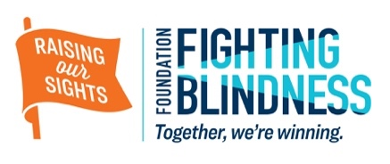

Dear [Name of your contact],

This year I am proud to play a part in the fight to end blinding retinal diseases, and I am asking for your help.

I will be [NAME ACTIVITY HERE - e.g., hosting golf tournament, running a marathon, asking friends and family for support], and I hope I can count on your support. I am making a commitment to raise funds and awareness for blinding retinal diseases because [YOUR ANSWER HERE]. Did you know -—

• More than 10 million Americans and millions more throughout the world are impacted by blinding retinal diseases — including aged-related macular degeneration and inherited retinal diseases (IRDs).
• Foundation Fighting Blindness has raised over $800 million in support of its efforts to reverse blindness and restore vision and is the world’s leading private source for IRD research funding.
• The Foundation is funding ground-breaking research and treatments that have restored vision in patients who were virtually blind from a childhood form of retinitis pigmentosa. The Foundation also funds research on potential drug therapies that slow or prevent the loss of retinal cells, thereby saving vision.

My personal goal is to raise [FUNDRAISING GOAL]. Please help me reach my goal by making a contribution now. Any gift, large or small, puts us one step closer to the cure.

Sincerely,
[YOUR NAME]

P.S. You can donate by going to my personalized fundraising page at [FUNDRAISING CAMPAIGN URL] or by sending your check to the Foundation Fighting Blindness along with the reply document below in the enclosed stamped, addressed reply envelope. Thank you so much!

Please detach and return the form below along with your gift in the enclosed postage-paid reply envelope.

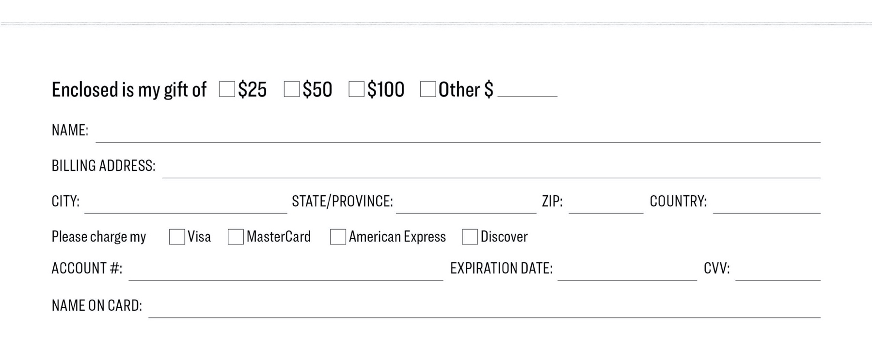

Yes, I support the work of [Your Name] to help end blinding retinal diseases!

Or donate online to my fundraising page at: [FUNDRAISING CAMPAIGN URL]

Please make checks payable to: Foundation Fighting Blindness. We are a 501(c)(3) non-profit, tax-exempt organization designated by the Internal Revenue Code. Our tax identification number is 23-7135845. Questions? Call 410-423-0600 and ask to speak to a Foundation Fighting Blindness representative. Payments can be sent to:
Foundation Fighting Blindness • Midwest P.O. Box 45933 • Baltimore, MD 21297-5933 • FightingBlindness.org
Fundraiser Designation: [YOUR NAME] and [ACTIVITY HERE] to benefit the Foundation Fighting Blindness.

